Technical Proposal
Update and Annual Maintenance Contract of Telecom Data Information System (DIS)
Prepared for Bangladesh Telecommunication Regulatory Commission (BTRC)
Prepared by: Riseup Labs

1. Executive Summary
Bangladesh Telecommunication Regulatory Commission operates the Telecom Data Information System (DIS) as a centralized regulatory platform for collecting operational, technical, and statistical data from licensed telecom operators. As data volume, monthly submissions, storage size, and reporting requirements have increased, the existing system requires a controlled optimization and modernization initiative rather than a full replacement.
This technical proposal presents a practical and cost-conscious approach to update, optimize, and maintain the existing DIS platform. The proposed approach focuses on database architecture optimization, delta-based data submission, big-data performance tuning, regulatory reporting enhancement, role-based dashboards, and 12 months of operation and maintenance support.
The proposal intentionally avoids unnecessary features and broad system redesign. All recommended activities are directly aligned with the ToR scope and are planned to minimize implementation risk, protect operational continuity, and ensure backward compatibility with the existing DIS database and workflows.

2. Understanding of the Assignment

2.1 Current Context
The current DIS platform is used by BTRC to collect recurring telecom operator data from license categories such as ISPs, IIGs, ILDCs, NIXs, NTTNs, and other relevant operators. The system stores large historical datasets and supports regulatory reporting and analytics.

2.2 Key Challenges Identified from the ToR
- Redundant full monthly dataset submissions create repeated data and storage growth.
- Large historical tables and unoptimized query paths affect reporting performance.
- Snapshot-based database design limits analytical flexibility and historical reconstruction efficiency.
- Regulatory users require improved dashboards, decision-support indicators, and drill-down reporting.
- The existing system must continue operating during optimization, modernization, and maintenance.

2.3 Proposal Principle
The primary principle is to modernize the existing DIS through controlled enhancement. This means retaining the current platform foundation, reviewing the existing architecture, optimizing the database and reporting layer, introducing delta-based submission where feasible, and improving dashboards without rebuilding the system from scratch.

3. Scope Alignment with ToR
ToR Scope Area | Proposal Response | Output / Evidence
System review and technical assessment | Review current DIS architecture, schema, workflows, tables, reports, and performance bottlenecks. | Assessment report, bottleneck list, optimization roadmap
Database architecture optimization | Separate master and transactional data layers, redesign selected tables for analytical efficiency, apply partitioning and indexing where needed. | Optimized schema plan, updated database objects, compatibility notes
Delta-based data submission model | Introduce change-driven submission for new, modified, or status-changed records with validation and historical reconstruction support. | Delta submission logic, validation rules, historical reconstruction method
Big-data performance tuning | Refactor slow queries, create materialized reporting views or summary tables, support background aggregation, async processing, and caching. | Performance-tuned queries, reporting views, aggregation jobs, benchmark results
Regulatory reporting and analytics enhancement | Improve growth or decline analytics, subscriber trends, cross-operator comparison, compliance gap identification, filters, and revenue analysis. | Updated report catalogue and dashboard indicators
UI/UX modernization and dashboard development | Develop role-based dashboards, decision indicators, interactive charts, drill-down navigation, and responsive enterprise interface. | Modernized dashboard screens and user acceptance records
Support and maintenance | Provide 24x7x365 support, escalation matrix, planned downtime communication, hardware support, and SLA-based service. | Support plan, escalation matrix, maintenance log, SLA reports

4. Proposed Technical Approach

4.1 Controlled Modernization of Existing DIS
The proposed technical approach will follow a controlled modernization model. The current DIS will remain the base system, while selected components are assessed, optimized, upgraded, and validated in phases. This reduces risk, avoids unnecessary redevelopment, and keeps the project aligned with the ToR requirement to enhance the existing platform.

4.2 Implementation Approach
Step 1: Inception and Assessment
Confirm scope, stakeholders, existing architecture, current database structure, reporting bottlenecks, hardware status, and operational constraints.
Step 2: Optimization Design
Prepare the database optimization design, delta submission model, dashboard structure, report improvement plan, deployment strategy, and risk mitigation plan.
Step 3: Development and Optimization
Implement approved database changes, query improvements, reporting views, validation rules, background processing, dashboards, and required UI refinements.
Step 4: Testing and Deployment
Conduct functional, regression, performance, security, compatibility, and testing before production deployment.
Step 5: Training, Handover, and Maintenance
Train BTRC officials, hand over manuals and documentation, and provide 12 months of operation and maintenance support.

5. Proposed Solution Components

5.1 System Review and Technical Assessment
- Review existing DIS architecture, application workflows, database schema, reporting modules, and integrations.
- Identify structural, performance, scalability, and operational bottlenecks.
- Prepare a practical optimization roadmap with priority, risk, and implementation sequence.

5.2 Database Architecture Optimization
- Separate master data, transactional data, reporting views, and historical data layers where technically feasible.
- Redesign selected high-volume tables to improve analytical efficiency without breaking existing data compatibility.
- Apply partitioning for large historical tables and improve indexing for frequently used filters and joins.
- Maintain backward compatibility with current DIS workflows and data access patterns.

5.3 Delta-Based Data Submission Model
- Replace unnecessary full snapshot submission with change-driven submission for new, modified, and status-changed records where applicable.
- Preserve historical reconstruction capability so regulatory users can still view historical states and trends.
- Introduce automated validation rules to reduce invalid or duplicate submissions.

5.4 Big-Data Performance Tuning
- Refactor slow queries and long-running report logic.
- Create materialized reporting views or summary tables for frequently accessed regulatory reports.
- Introduce scheduled background aggregation and asynchronous processing for heavy reporting workloads.
- Cache frequently accessed reference datasets and report outputs where appropriate.

5.5 Regulatory Reporting and Analytics Enhancement
- Improve reporting for growth vs. decline, active vs. inactive subscriber trends, cross-operator comparison, compliance gaps, and revenue analysis.
- Enable multi-dimensional filtering by operator type, reporting period, service category, geographic dimension, and compliance status where data is available.
- Keep analytics focused on regulatory decision support and avoid unnecessary advanced AI/ML features not requested in the ToR.

5.6 UI/UX Modernization and Dashboard Development
- Develop role-based dashboards for BTRC users according to access level and reporting responsibility.
- Use interactive charts, indicators, and drill-down navigation for approved reporting areas.
- Improve responsiveness, usability, and enterprise-grade visual consistency without changing the full system unnecessarily.

6. Proposed Technical Stack
Because the DIS will not be developed from scratch, the final stack will be confirmed after reviewing the existing source code, database, deployment environment, and hardware. The following stack is proposed as a compatible modernization and optimization stack, subject to existing platform compatibility.
Layer | Recommended Technology / Tooling | Purpose
Application Layer | Existing DIS technology stack to be retained; compatible enhancement if required | Avoid full redevelopment and maintain continuity
Backend Services | Existing backend language/framework; REST/JSON APIs or internal service endpoints as applicable | Support dashboard, validation, reporting, and delta submission enhancements
Database | Existing RDBMS to be retained where possible; schema redesign, indexing, partitioning, views, materialized views or summary tables | Improve storage efficiency, query performance, and reporting scalability
Frontend/UI | Existing UI technology with selective modernization; HTML5, CSS3, JavaScript/TypeScript, Bootstrap or compatible component library if suitable | Modern dashboards and responsive enterprise interface
Reporting & Analytics | SQL reporting views, materialized views or summary tables, charting library compatible with the existing stack | Regulatory reporting, drill-down dashboards, and indicators
Background Processing | Cron jobs, scheduler, worker service, or queue mechanism compatible with current environment | Async aggregation, cache refresh, and heavy report processing
Security | Role-based access control, audit logs, HTTPS/TLS, secure coding practices, backup and recovery controls | Data protection and controlled user access
Deployment & Hosting | Existing BTRC hosting/hardware environment; staging and production deployment process | Minimize infrastructure disruption and migration risk
Monitoring & Support | Server/database monitoring, error logging, incident tracking, SLA reporting | Operational maintenance and support visibility

7. Development and Implementation Methodology

7.1 Methodology Overview
A phased, risk-controlled, and approval-driven methodology will be followed. Each phase will produce a reviewable output before moving to implementation. This is suitable because the system is already operational and must not be disrupted by unnecessary redevelopment.

7.2 Phase-wise Methodology
Phase | Key Activities | Client Involvement | Output
Inception & Assessment | Kickoff, system review, database review, report review, hardware status review, bottleneck identification | Provide access, nominate focal points, validate issues | Inception report and assessment findings
Design Approval | Optimization design, dashboard wireframes, delta model, deployment plan, risk mitigation plan | Review and approve design before development | Approved design and implementation plan
Development & Optimization | Database optimization, query tuning, delta submission logic, reporting views, dashboard modernization | Provide feedback in review sessions | Optimized DIS components
Testing & Deployment | Functional, regression, performance, security, QA, staging and production deployment | Participate in QA | Deployment acceptance
Training & Handover | Training for BTRC officials, user manual, technical documentation, source and relevant documents handover | Nominate trainees and validate training completion | Training completion and handover pack
Support & Maintenance | SLA support, incident handling, preventive maintenance, hardware support, reporting | Report issues and approve planned downtime | Monthly support and maintenance records

8. Testing and Quality Assurance
Quality assurance will focus on confirming that the optimized DIS remains functionally correct, performs better under large datasets, and remains compatible with existing workflows and historical data.
- Functional Testing: Verify all updated workflows, submission rules, validation rules, reports, dashboards, and role-based access.
- Regression Testing: Ensure existing DIS functions continue to work after database and reporting optimization.
- Data Validation Testing: Validate delta submission, duplicate prevention, modified/status-changed record handling, and historical reconstruction.
- Performance Testing: Benchmark selected slow queries, high-volume reports, dashboard response time, aggregation jobs, and historical table access before and after optimization.
- Compatibility Testing: Check compatibility with existing browsers, server environment, database version, and hardware constraints.
- Security Testing: Review authentication, authorization, role access, input validation, session controls, and common web application risks.
- Deployment Verification: Verify production deployment, configuration, backup, rollback readiness, and service availability after go-live.



9. Deliverables
Deliverable | Description
Inception Report | Revised scope, deliverables, timeline, risk and mitigation plan, and stakeholder feedback summary.
Technical Assessment Report | Architecture review, database schema review, workflow review, reporting review, bottlenecks, and optimization roadmap.
Approved Optimization Design | Database optimization plan, delta submission design, reporting enhancement design, dashboard design, and deployment plan.
Optimized DIS System | Updated DIS components covering approved scope, database optimization, reporting improvements, dashboard modernization, and validation logic.
Testing and QA Report | Test cases, test results, performance comparison, QA observations, and acceptance evidence.
Training and User Manual | Training for minimum 15 BTRC officials, operating manual, and user guidance for updated features.
Technical Documentation and Source Code | Relevant source code, database scripts, configuration notes, deployment notes, and maintenance instructions.
Final Report | Activities completed, findings, recommendations, source codes, relevant documents, and support transition plan.
01 Year Operation, Maintenance, and Managed Service | Support and maintenance service for 12 months as per SLA and escalation matrix.

10. Implementation Timeline
The proposed implementation timeline: 2 months

11. Support and Maintenance Plan
- Provide 24x7x365 support and services through defined communication channels.
- Maintain an escalation matrix covering first-level support, technical support, database support, and project management escalation.
- Maintain DIS system availability target as per ToR, excluding planned downtime.
- Communicate planned downtime in advance and schedule it during off-peak hours.
- Provide support for existing DIS hardware including servers, switches, and related equipment within the agreed scope.
- Maintain incident logs, resolution notes, monthly support summary, and preventive maintenance records.

12. Risk and Mitigation Plan
Risk | Potential Impact | Mitigation
Incomplete existing documentation | Assessment may take longer than expected. | Conduct code/database walkthroughs with BTRC technical team and document findings during inception.
Large historical data volume | Optimization and testing may require careful scheduling. | Use staged optimization, backup, partitioning plan, and controlled scripts tested in staging first.
Production disruption risk | Service interruption could affect regulatory operations. | Use staging environment, rollback plan, off-peak deployment, and planned downtime communication.
Unknown legacy dependencies | Changes may affect existing reports or workflows. | Conduct regression testing and preserve backward compatibility.
Hardware limitations | Performance gains may be limited by server capacity. | Assess hardware early and optimize within existing capacity; recommend only necessary hardware actions if required.
Delayed feedback or access | Timeline may be affected. | Define focal persons, access checklist, review schedule, and acceptance process during inception.

13. Technical Diagrams

Figure 1: High-Level DIS Optimization Architecture
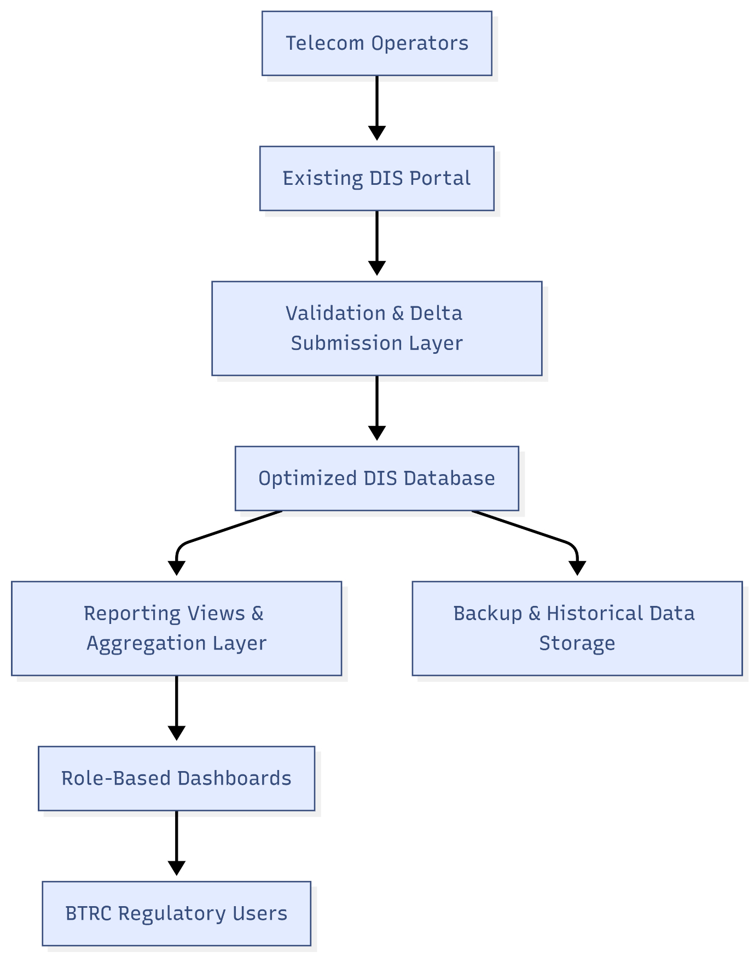

Figure 2: Delta-Based Data Submission Flow
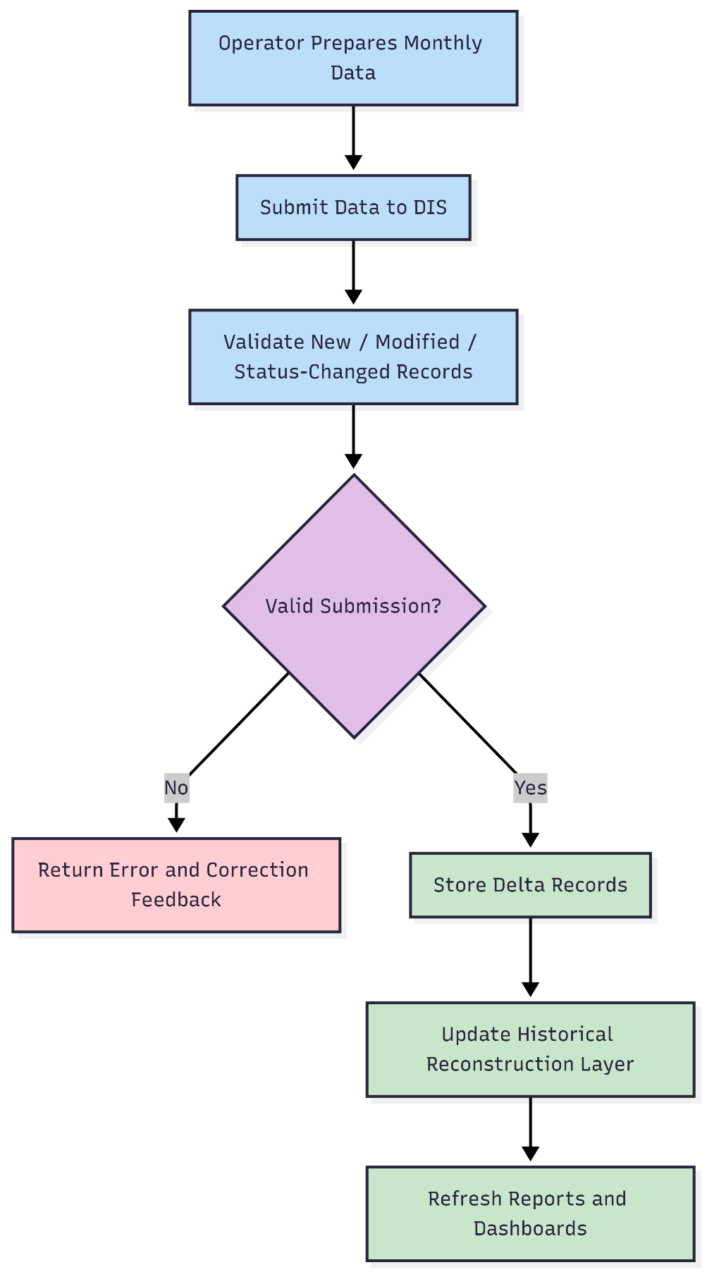

14. Assumptions, Dependencies, and Exclusions

14.1 Assumptions
- BTRC will provide access to the existing DIS source code, database schema, server environment, and relevant documentation.
- BTRC will nominate technical and functional focal persons for review, QA, training, and approval.
- The existing DIS platform and hardware will be retained unless assessment identifies a critical issue requiring specific action.
- Production deployment will be scheduled in coordination with BTRC and during agreed off-peak time.

14.2 Key Dependencies
- Availability of database backup and staging/test environment.
- Access to existing reports, workflows, operator submission formats, and user roles.
- Timely feedback on design, dashboard indicators, testing, and acceptance.
- Availability of BTRC officials for training and QA.

14.3 Exclusions
- Full redevelopment of DIS from scratch is excluded.
- Unrelated new modules, AI/ML features, mobile applications, and new third-party integrations are excluded unless explicitly required by BTRC later.
- Major hardware replacement is excluded unless separately approved after technical assessment.
- Changes outside the ToR scope are excluded from this proposal.

15. Conclusion
The proposed solution provides a controlled, practical, and cost-conscious modernization path for the existing Telecom Data Information System. It focuses on the exact priorities identified in the ToR: database optimization, delta-based data submission, performance improvement, regulatory analytics, dashboard modernization, and reliable 12-month support and maintenance.
By retaining the existing platform foundation and improving the most critical technical and reporting layers, the project can deliver measurable operational benefit while minimizing implementation risk, avoiding unnecessary cost, and protecting continuity of BTRC regulatory operations.

